Nike PG 2

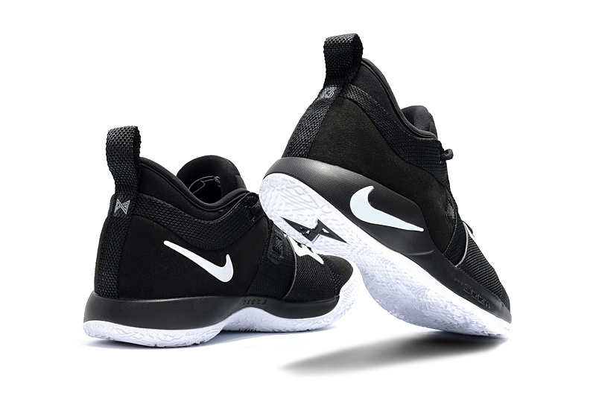

Product code: 1021

The PG 2 Basketball Shoe is designed for the game's most versatile players. It's light yet strong, with supportive straps and comfortable cushioning that responds to every fast, focused step.

LeBron 15

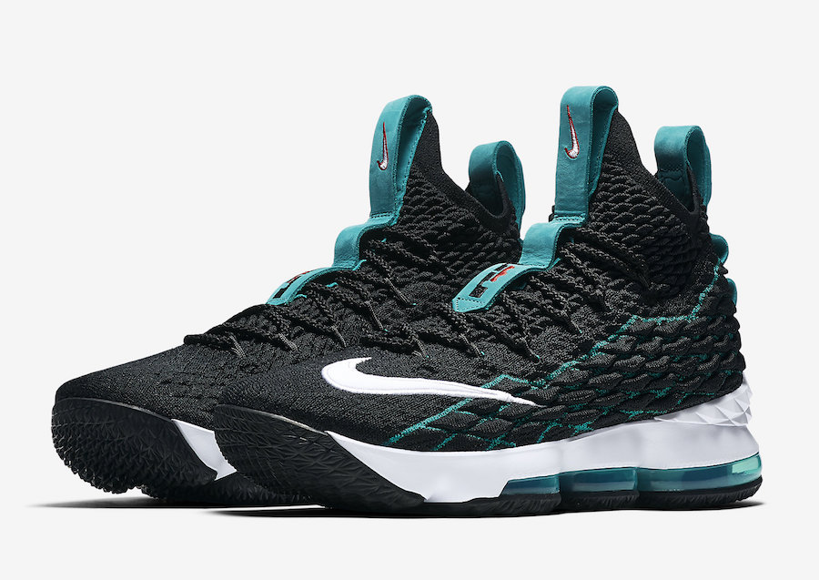

Product code: 1022

The LeBron 15 Basketball Shoe features a new kind of Flyknit and a powerful combination of cushioning designed to meet the demands of explosive players like LeBron.

# Nike Hyperdunk 2017 (Team)

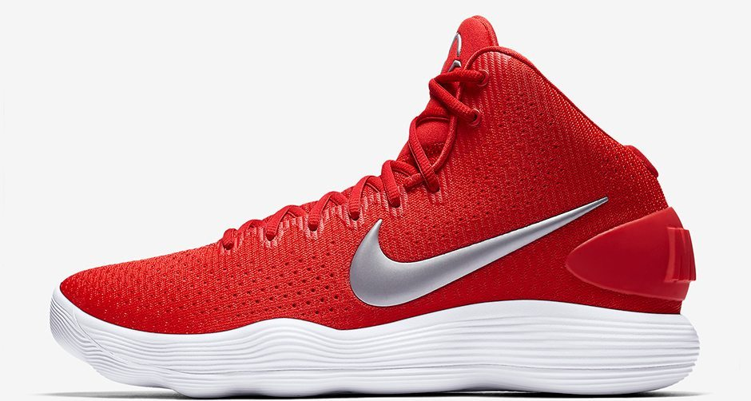Product code: 1023

The Nike Hyperdunk 2017 Women's Basketball Shoe features the latest revolution in basketball cushioning: ultra-responsive Nike React foam designed to help you play harder and go further.

# Kobe A.D. NXT 360

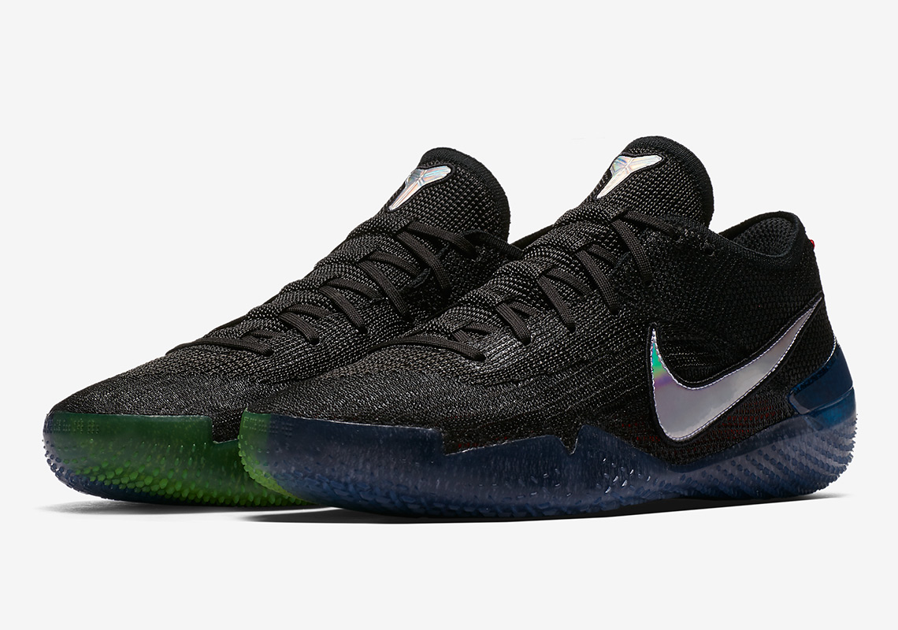

Product code: 1024

The Kobe A.D. NXT 360 Basketball Shoe features a Flyknit upper that wraps your foot for lightweight support. Responsive cushioning and excellent traction help you push past your potential and your opponent.

# LeBron Soldier XII

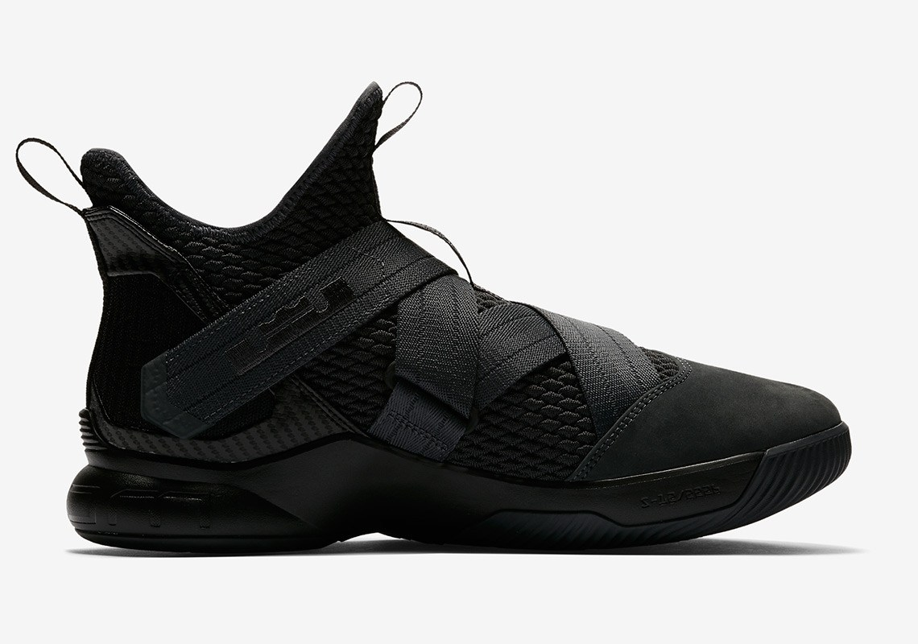

Product code: 1025

The LeBron Soldier XII Men's Basketball Shoe delivers lightweight, responsive comfort on the court with Nike Zoom Air cushioning. Adjustable hook-and-loop straps offer personalised, secure lockdown.